Lab Exercise 6- Docker-Compose file

Objective:
Set up a WordPress environment using Docker Compose, including a MySQL database as the backend.
Prerequisites:
- Docker and Docker Compose installed on your system.
Step 1: Create a docker-compose.yml File
- In the project directory, create a file named docker-compose.yml.
- Add the following content to docker-compose.yml:

docker-compose.yml
version: '3.8'

services:
wordpress:
image: wordpress:latest
ports:
- "8002:80"
environment:
WORDPRESS_DB_HOST: db:3306
WORDPRESS_DB_USER: wp_user
WORDPRESS_DB_PASSWORD: wp_pass
WORDPRESS_DB_NAME: wp_database
depends_on:
- db

db:
image: mysql:latest
environment:
MYSQL_ROOT_PASSWORD: root_password
MYSQL_DATABASE: wp_database
MYSQL_USER: wp_user
MYSQL_PASSWORD: wp_pass
volumes:
- db_data:/var/lib/mysql

volumes:
db_data:

Step 2: Start the Containers
- Run the following command to start the containers:
docker-compose up -d

- Docker Compose will download the necessary images (WordPress and MySQL) and start both services.
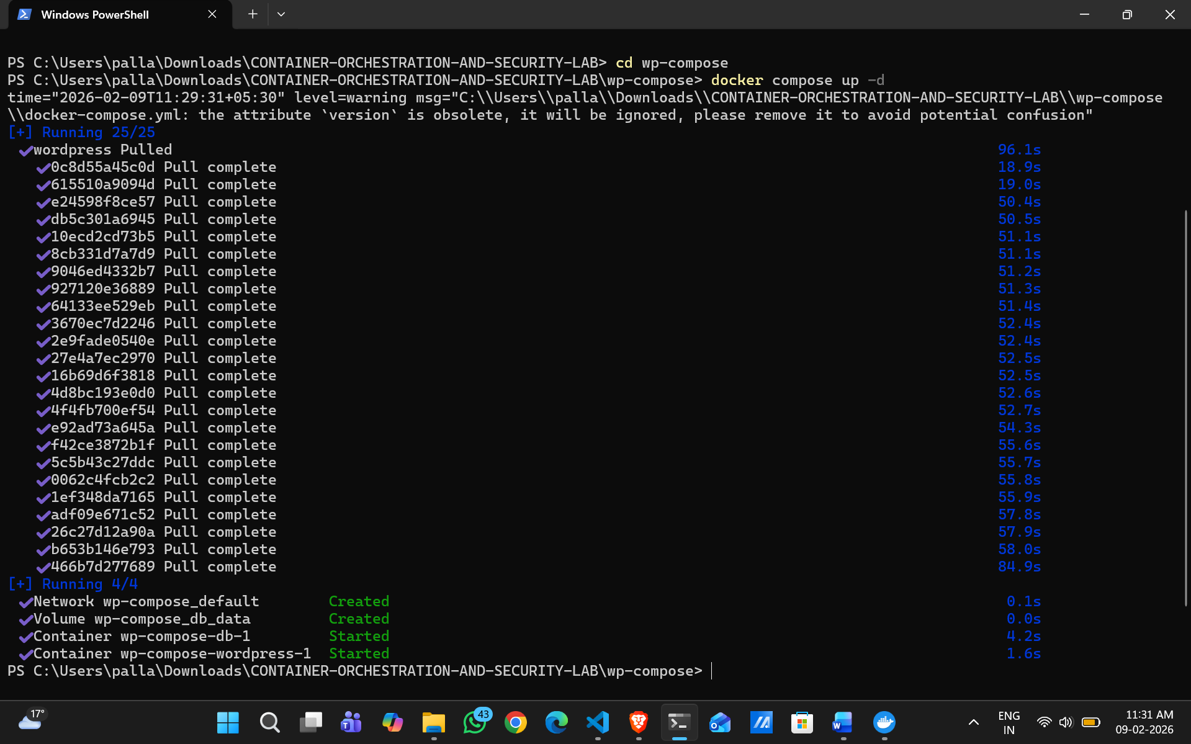
Step 4: Access WordPress
- Open your web browser and go to http://localhost:8002
- Follow the WordPress installation steps to set up your site.
Step 5: Stop and Remove Containers
To stop the containers and remove the associated resources, run:
docker-compose down

Explanation of docker-compose.yml:
- wordpress: Sets up the WordPress container, mapping port 80 inside the container to port 8002 on your local machine.
- db: Sets up the MySQL container with a volume (db_data) for persistent storage.
Additional Notes:
- Modify the environment variables as needed for different configurations.
- To view logs, use docker-compose logs -f.
This setup allows you to quickly start a WordPress site locally and experiment with configurations.
